**3. . Suppose there are 2 Users and they are having Create, Read, Edit access on Account Object with the same profile but we want to open up the access for one user to delete how will you implement the Security setting.**

**Solution:**

**Step 1:** we need create a profile for the two user which has the access to Create, Read, Edit for follow as per. Setup-quick search[profile]

Step 2:

Click on the new to create a new profile along with the label and Api

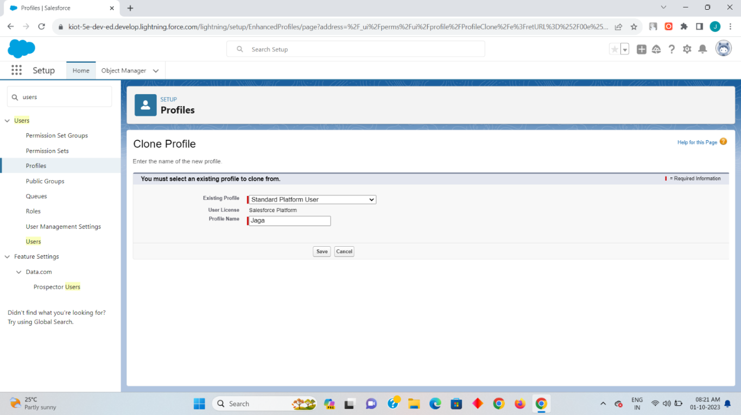

Here I had made it my profile name as Jaga and the existing profile as Standard Platform User.

Step 3:

Now click on the edit and scroll down to custom object settings and enable the read,create,edit and view options. After that click on save.

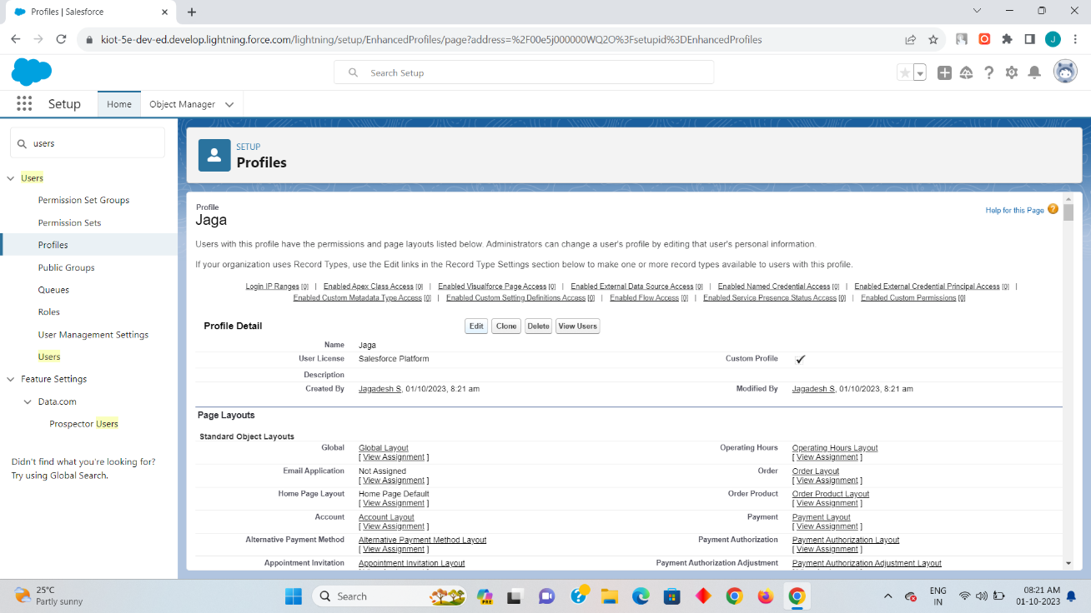

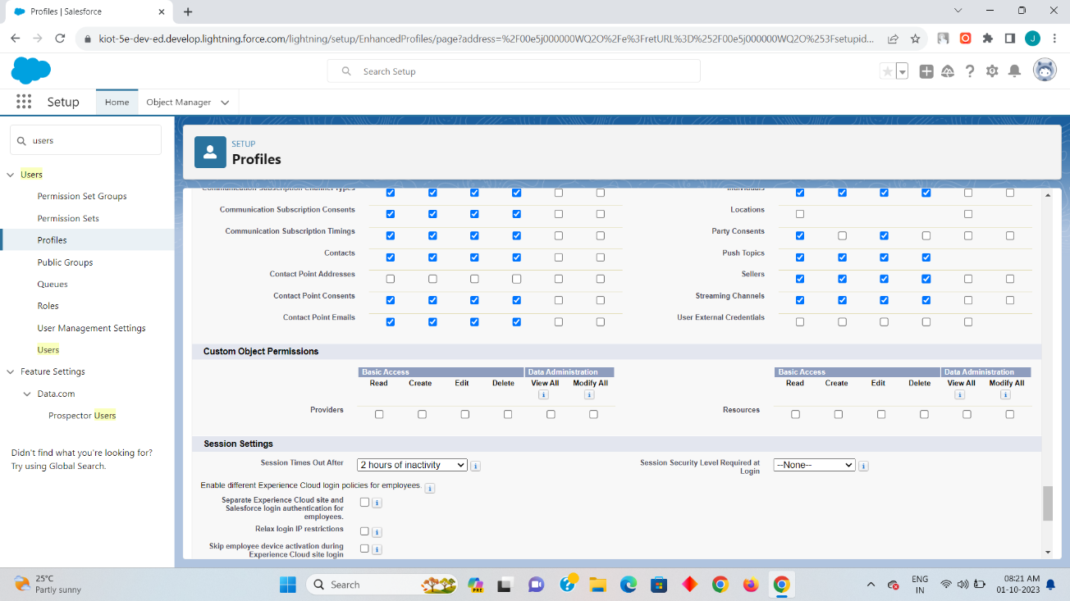

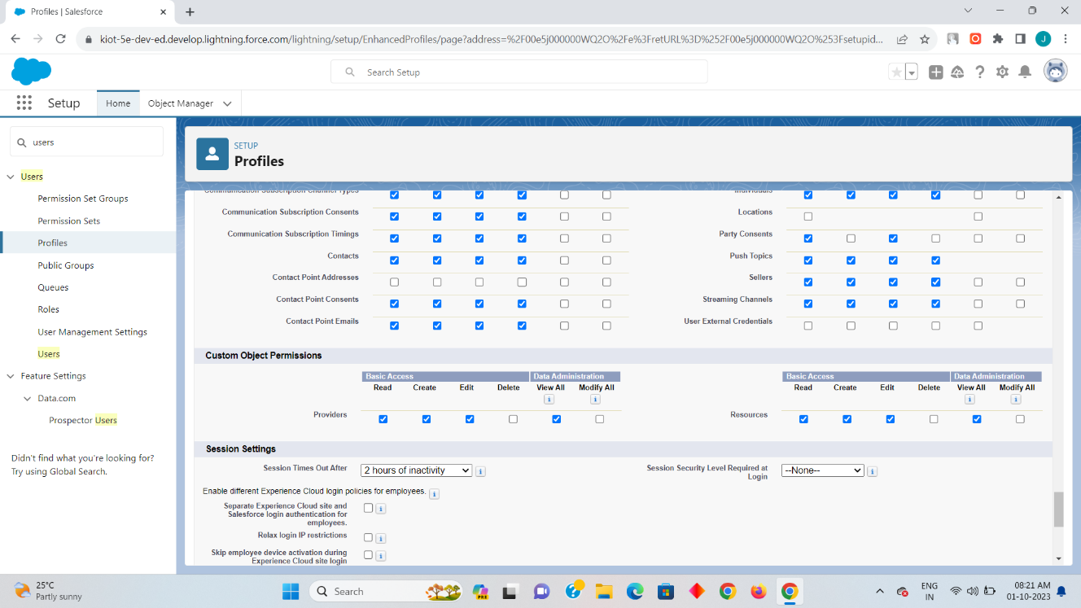

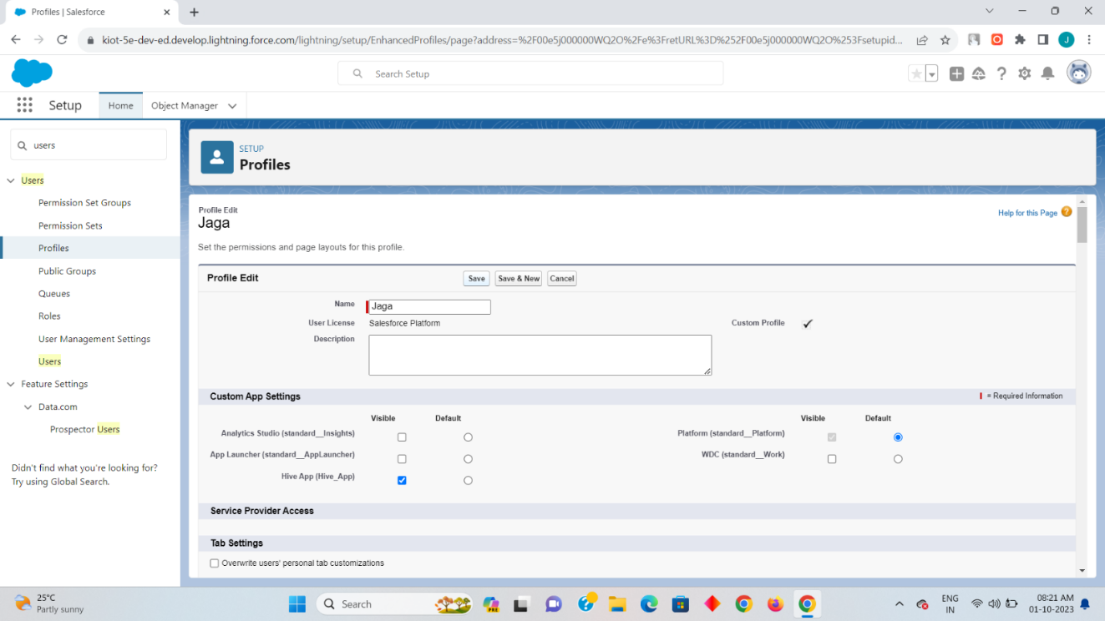

Step 4

Now you can preview your created profile on the profile option here my profile name jaga has been created with the access of read,create,edit along with view on it

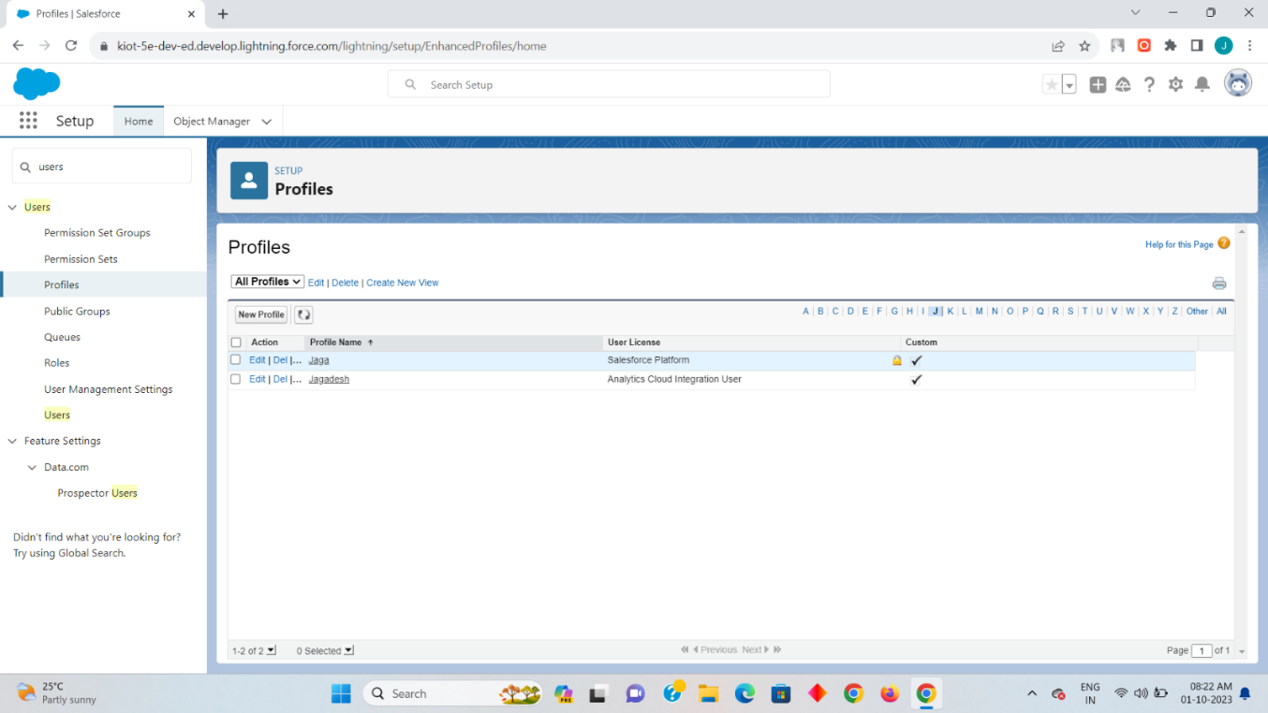

Step 5:

Now create two users by enter into the Setup-quick search[user] and then click on new user after clicking that you need to create two user along with the profile as Jaga which we have created on the step 2.once the one user has been created click on the save&new so that you can create the second user and there the user name can been created with alternate name but with the same user profile and once the two user are create click on save.

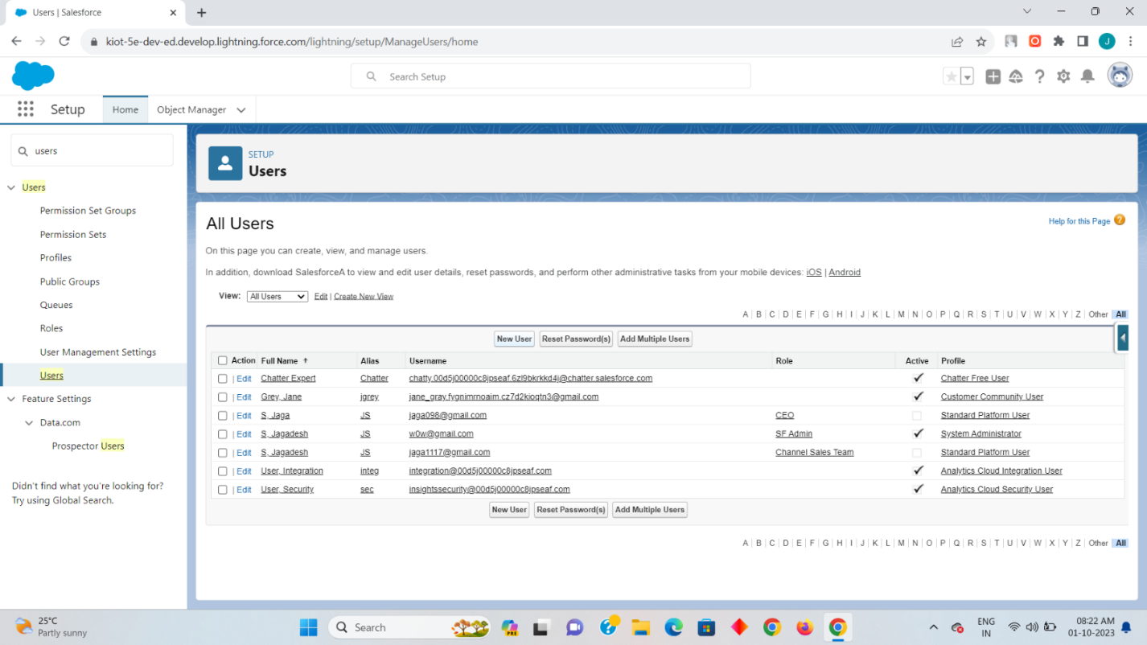

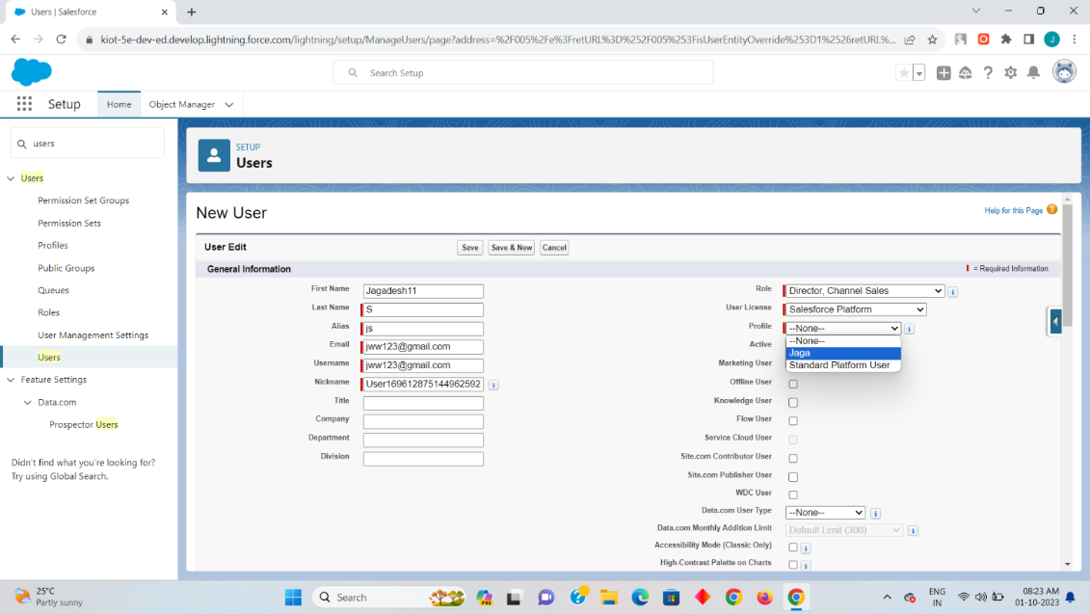

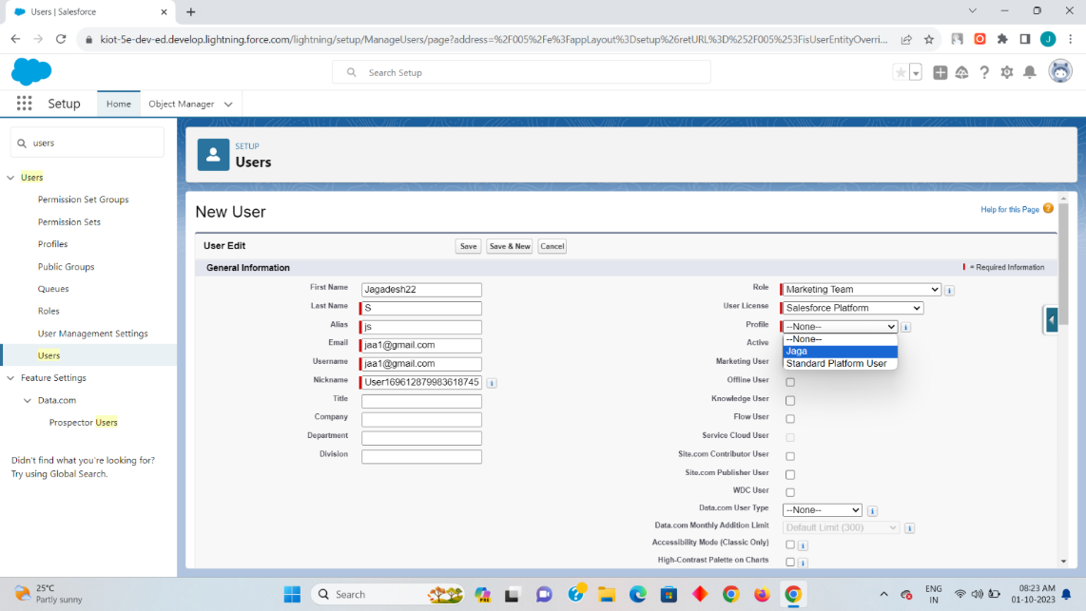

Now you can preview your two user that you have created in my side I had create the two users a Jagadesh11 and Jagadesh22 as a director channel sales with the marketing team.

Step 6:

Now the two user as been created with the profle so that two user can perform the Create, Read, Edit and view on both the user. So as per the given task we need to allocate a specific access as delete on one user for that we need create a permission set for one user so it can created as

setup-quick search[permission set]-new-fill label name [auto select the API name]-click on save-object settings-accounts.

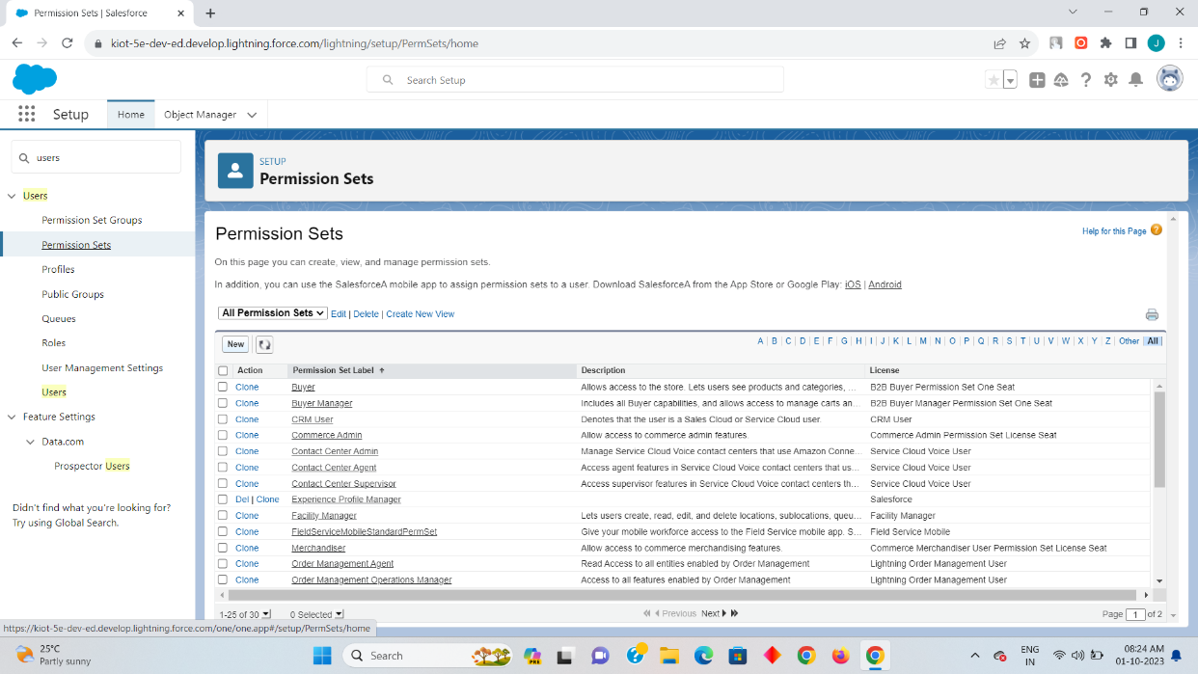

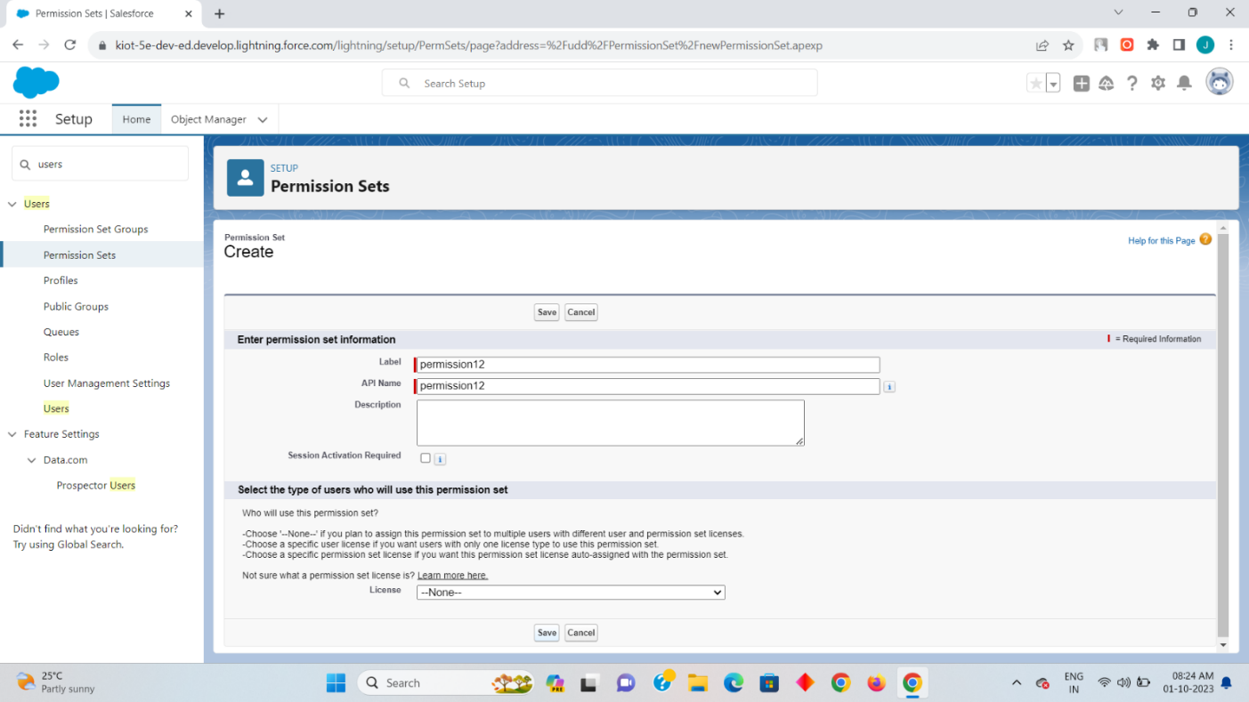

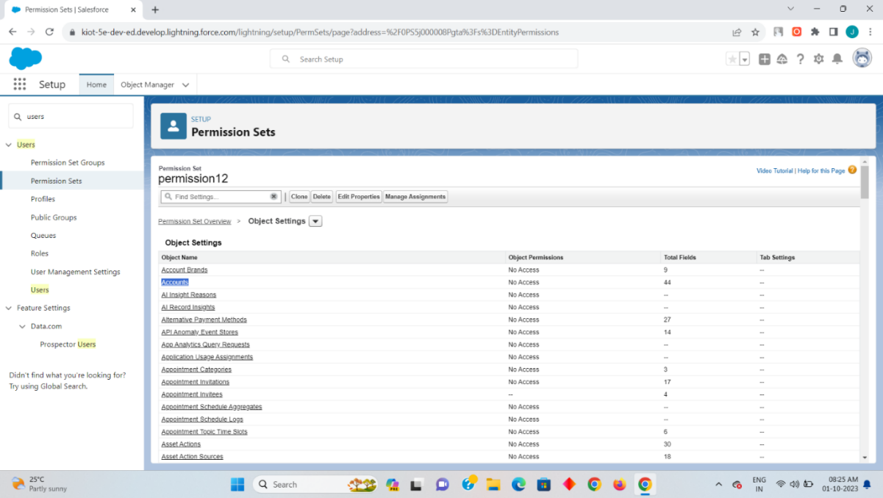

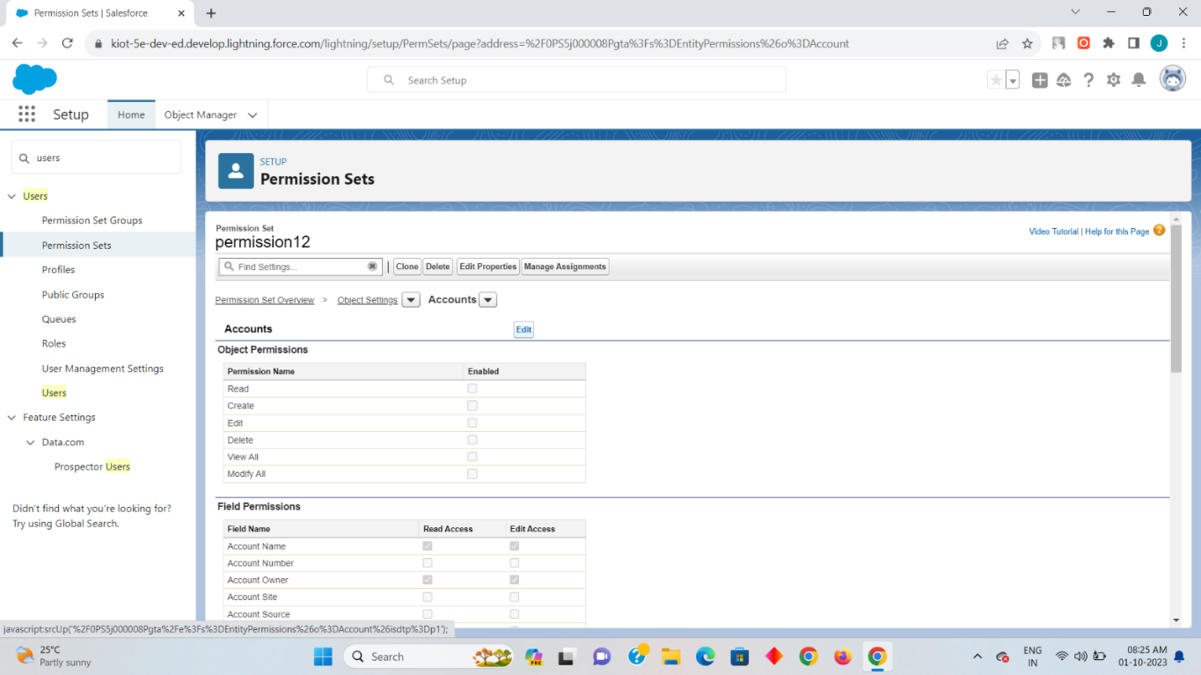

**Step 7:**

Now to give the specific delete access to the user click on edit on the Account and then enable the read,create,edit and the delete on it so that the permission set will have a specific special access on it. once it has been done click on save and then click on manage assignment.

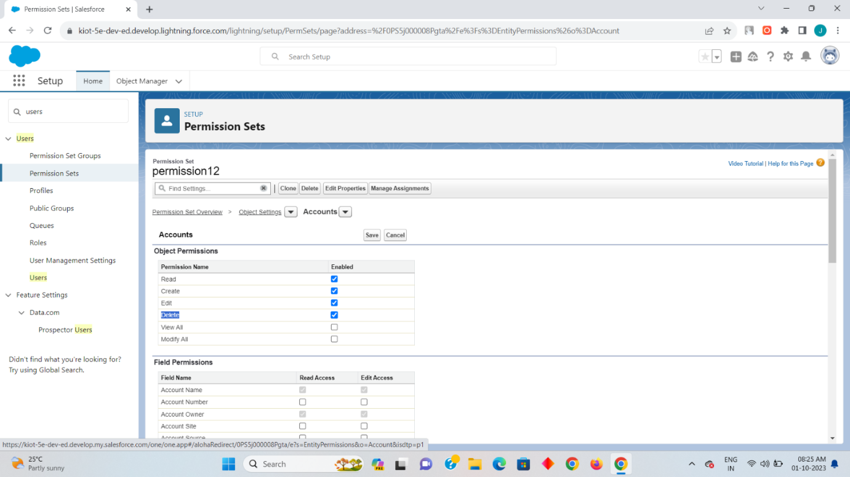

Step 8

Now click on add assignment there you will find your two created users click on any one user to give a special access as delete on it and then click on assign so that the specific selected user can have a special access as delete on it.

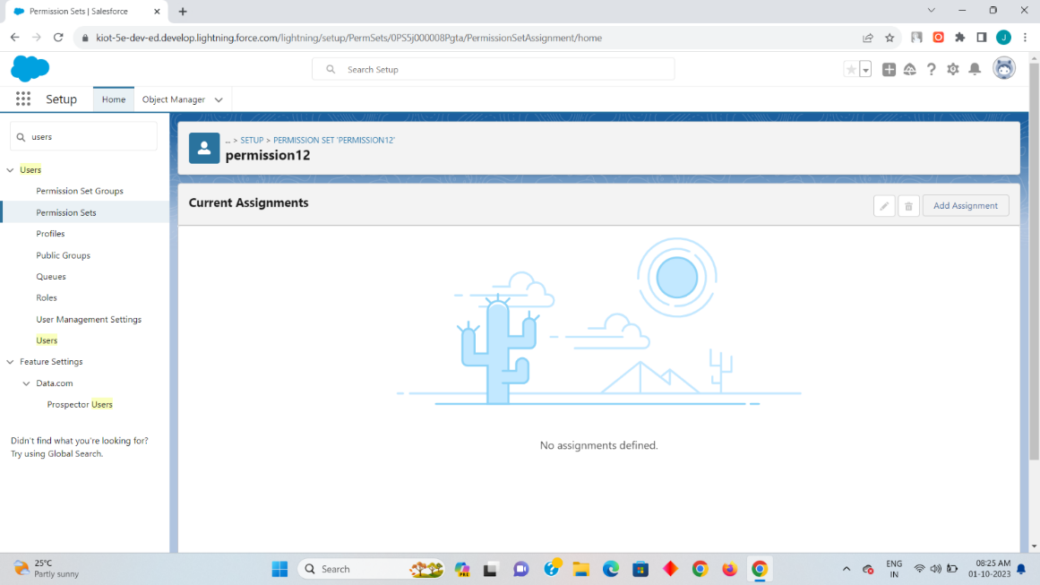

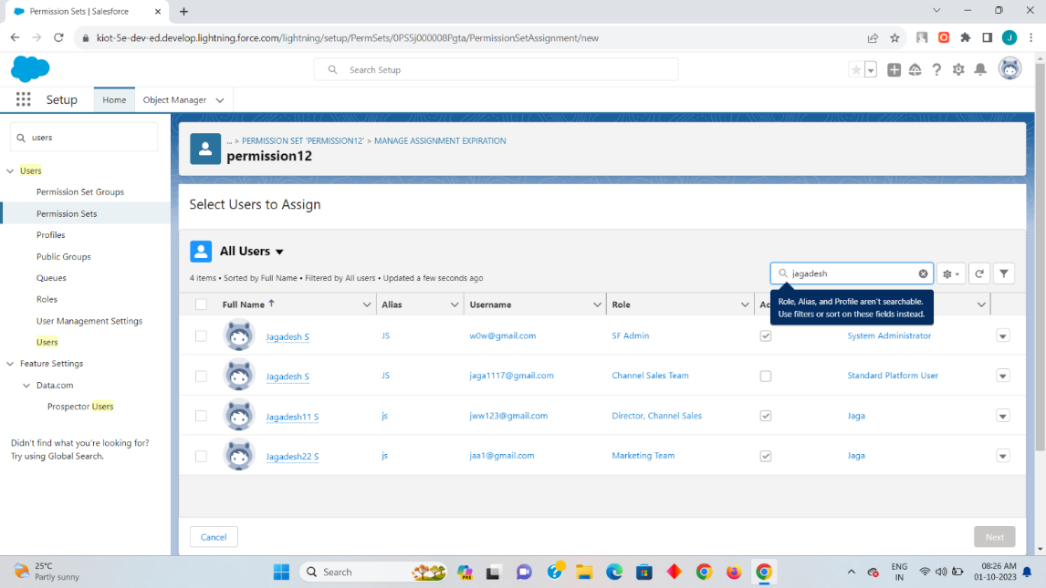

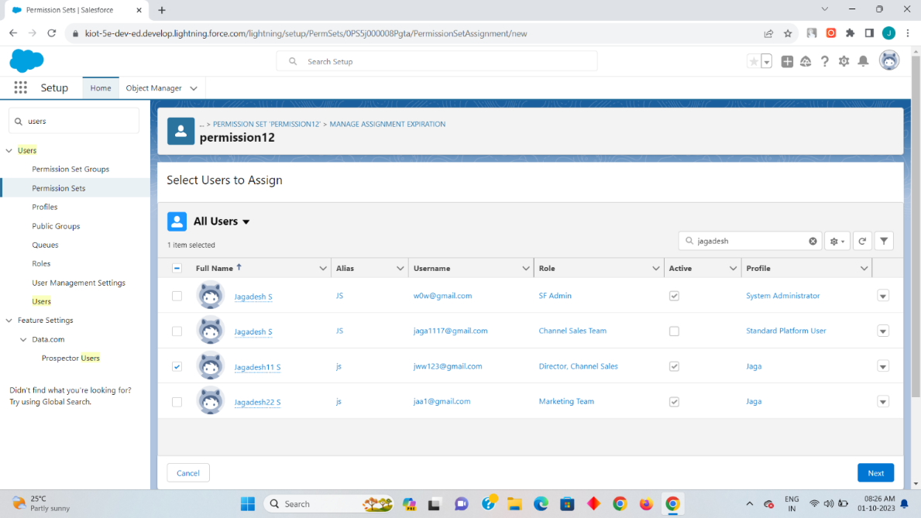

Click on next.

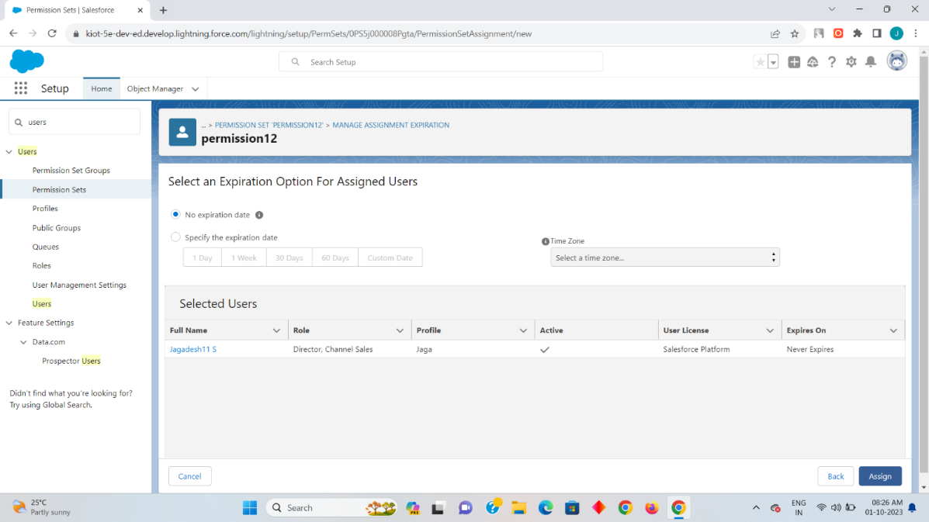

Now click on Assign.

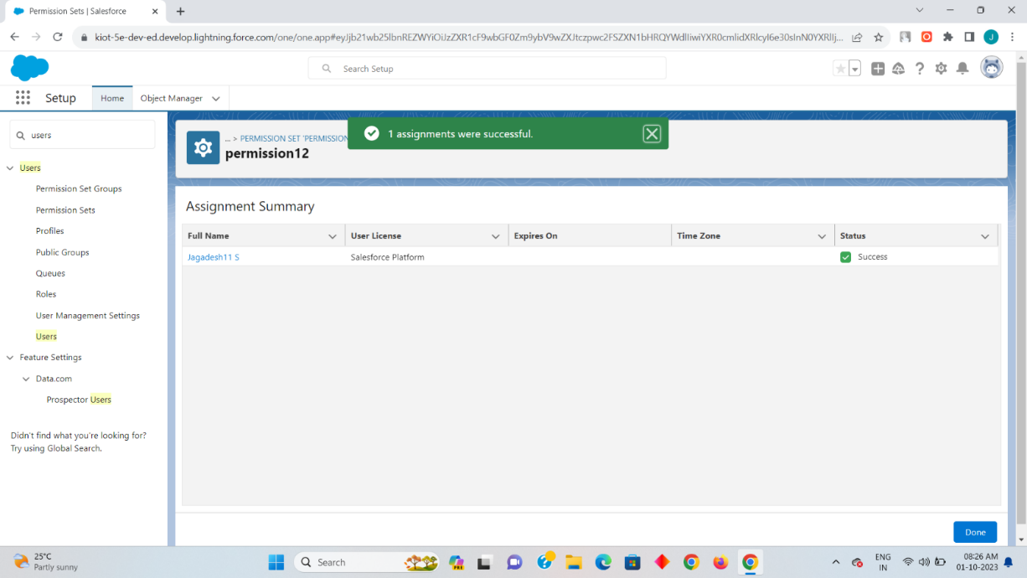

Now the specific access for the Jagadesh11 user has been assigned successfully.